AWS Lambda Quick-Start: Function Creation & Testing

Description
This sequence illustrates the end-to-end workflow of a developer using the AWS Management Console to deploy a serverless "Hello World" application.

Step 1: Landing Page You started at the AWS Lambda console home page and clicked the orange "Create a function" button.

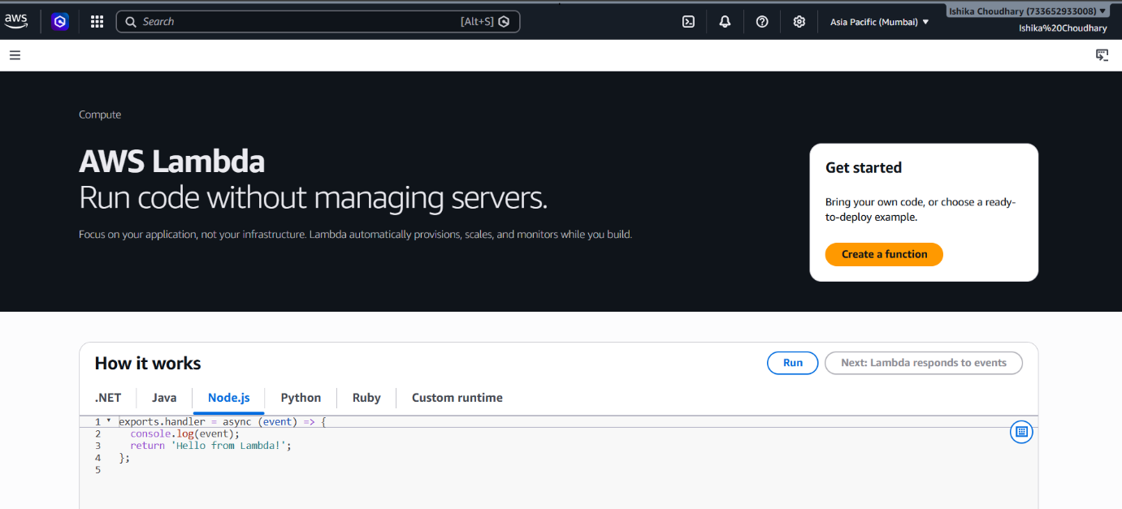

Step 2: Configuration You chose "Author from scratch." You named the function python4 (though you selected the Node.js 24.x runtime) and kept the default permissions.

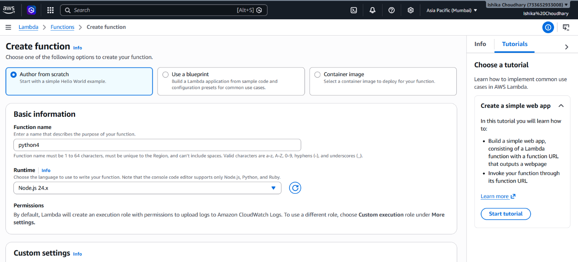

Step 3: Successful Creation A "Getting started" overlay appeared, confirming the function was created. You dismissed this to view the code editor.

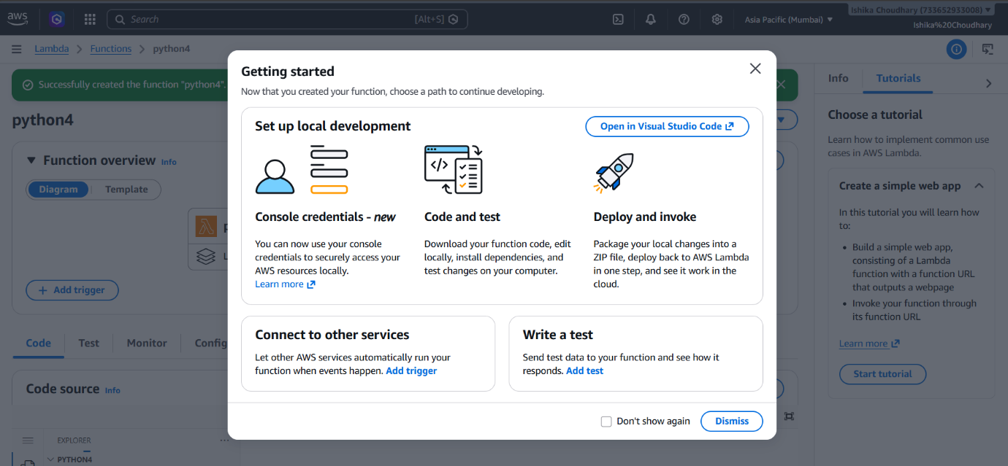

Step 4: Code Source Overview The console displayed the boilerplate code in the index.mjs file. The function is set up to return a "Hello from Lambda!" message.

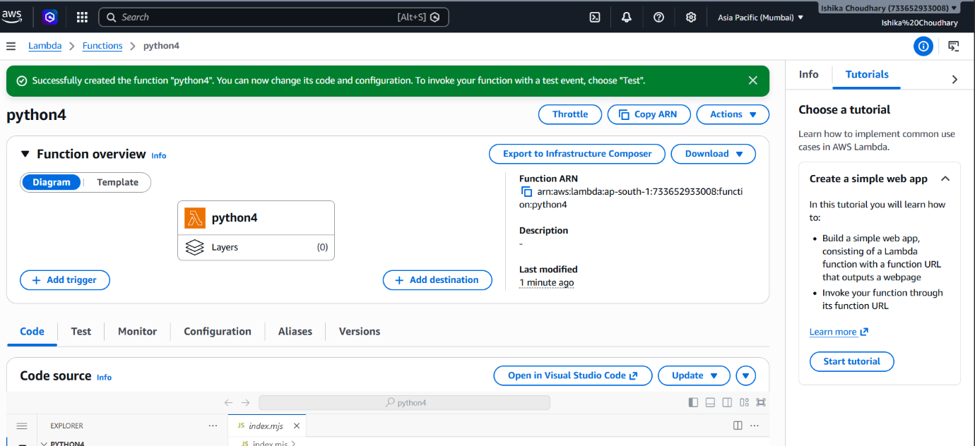

Step 5: Creating a Test Event You opened the "Create new test event" pane. You named the event python4, kept it "Synchronous," and saved it.

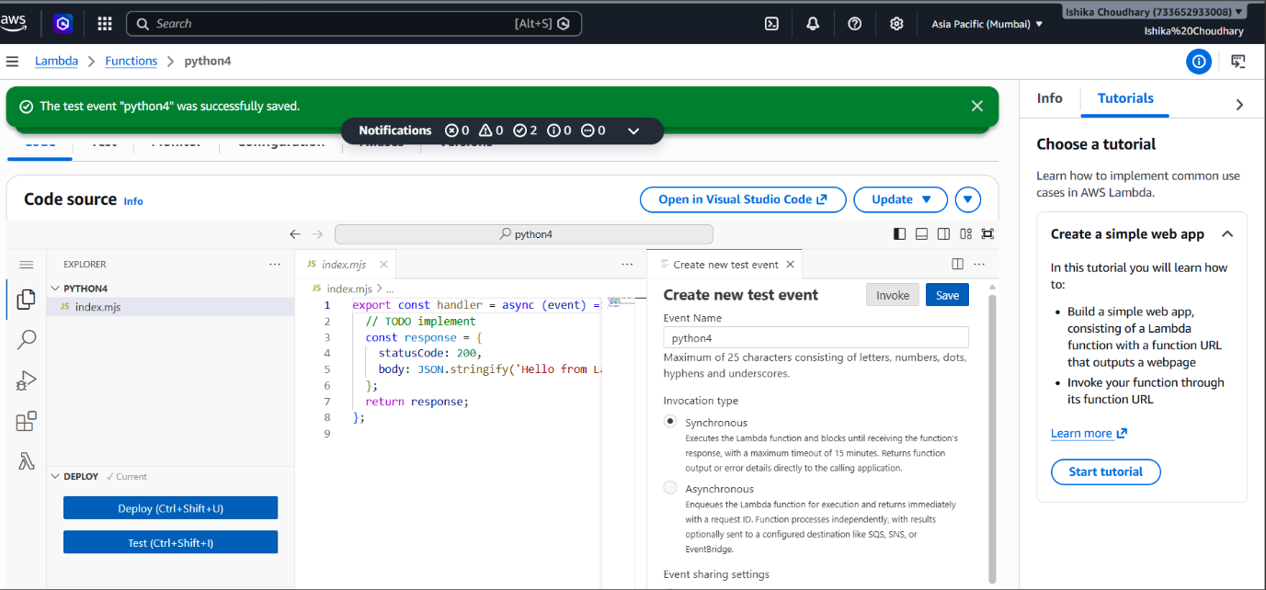

Step 6: Execution and Results You clicked the "Test" button. The "Execution Results" tab opened at the bottom, showing a Status: Succeeded with the JSON response: {"statusCode": 200, "body": "Hello from Lambda!"}.

